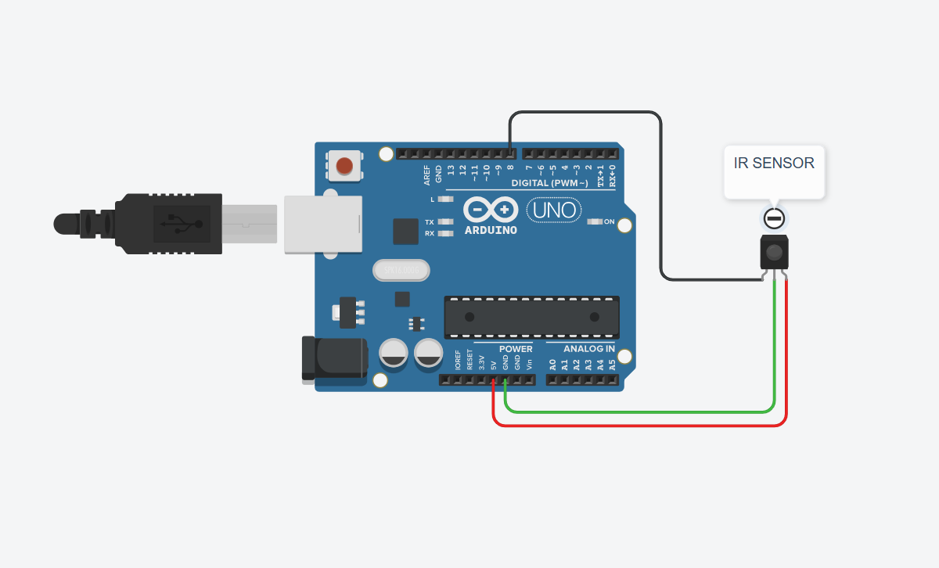
// --- IR Proximity Sensor Code ---
const int irPin = 8; // Pin connected to the IR sensor's OUT

void setup() {
Serial.begin(9600);
pinMode(irPin, INPUT);
Serial.println("IR Sensor Test Initialized");
}

void loop() {
int sensorState = digitalRead(irPin);
// The module outputs LOW when it detects an object
if (sensorState == LOW) {
Serial.println("Object Detected");
} else {
Serial.println("No Object");
}
delay(500);
}

Figure 1: IR Proximity Sensor.
Expt No:  01 | SENSOR INTEGRATION AND DATA ACQUISITION
Date:
/ /2025

- AIM:
To interface three different types of sensors—an IR proximity sensor, an HC-SR04 ultrasonic distance sensor, and a DHT11 temperature & humidity sensor with an Arduino UNO R3 microcontroller to understand their working principles and acquire distinct types of data from the environment.

- APPARATUS REQUIRED:
  - Microcontroller: Arduino UNO R3,
  - Sensors:
    - IR (Infrared) Proximity Sensor Module,
    - Ultrasonic Distance Sensor (HC-SR04),
    - Temperature & Humidity Sensor (DHT11).
  - Software: Arduino IDE with "DHT sensor library" by Adafruit installed,
  - Components: Jumper Wires, USB-B Cable, Breadboard (optional),
  - Miscellaneous: Object for detection, Measuring tape.

- THEORY:
- IR Proximity Sensor: This sensor uses an IR LED (transmitter) and a photodiode (receiver). The LED emits infrared light. If an object is in front of the sensor, the light reflects off it and is detected by the photodiode. The onboard comparator circuit then outputs a digital LOW signal to indicate presence and a HIGH signal for absence.
- Ultrasonic Sensor (HC-SR04): This sensor measures distance using sonar. It transmits a high-frequency ultrasonic pulse and listens for its echo. The time difference between the transmission and reception of the pulse (time-of-flight) is measured. Since the speed of sound is known (~343 m/s), the distance can be calculated using the formula: Dist. = (Time × Speed of Sound) / 2.
- DHT11 Sensor: This is a digital sensor that measures ambient temperature and relative humidity. It uses a capacitive humidity sensor and a thermistor. An internal chip performs analog-to-digital conversion and outputs a digital signal with the temperature and humidity data, which requires a specific library to decode.

- PROCEDURE:

- IR Proximity Sensor:
  - Connections:
    - IR Sensor VCC → Arduino 5V,
    - IR Sensor GND → Arduino GND,
    - IR Sensor OUT → Arduino Digital Pin 8.
  - Code: Upload the following sketch to the Arduino.
  - Observation: Open the Serial Monitor. Place your hand in front of the sensor and observe the output changing from "No Object" to "Object Detected".

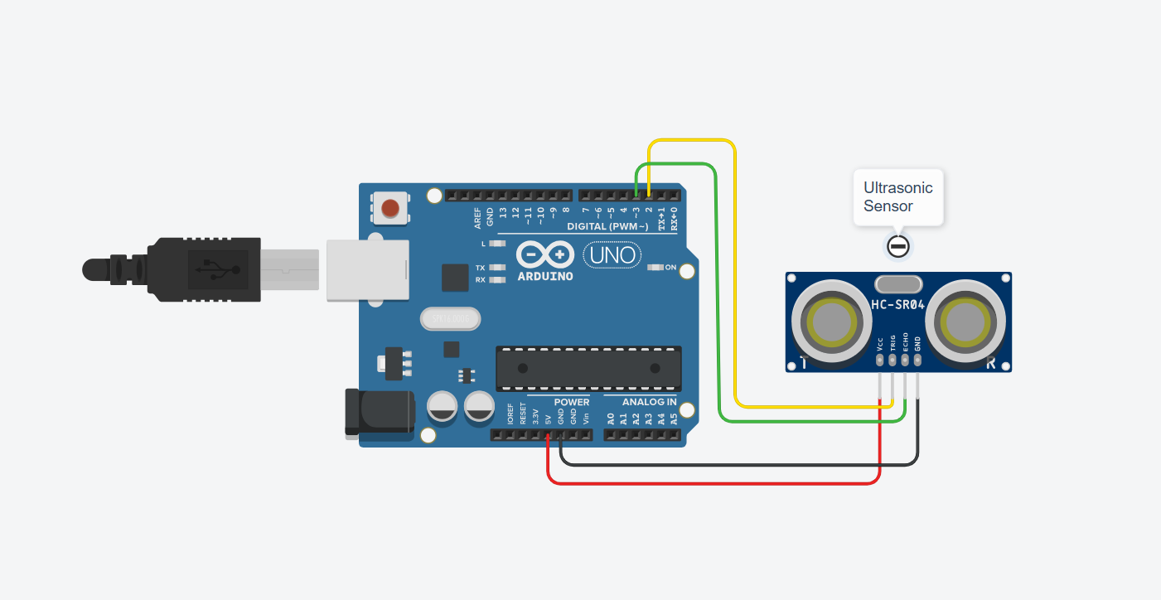
Figure 2: Ultrasonic Distance Sensor.
// --- Ultrasonic Distance Sensor Code ---
const int trigPin = 2;
const int echoPin = 3;
long duration;
float distance;

void setup() {
Serial.begin(9600);
pinMode(trigPin, OUTPUT);
pinMode(echoPin, INPUT);
Serial.println("Ultrasonic Sensor Test Initialized");
}

void loop() {
digitalWrite(trigPin, LOW);
delayMicroseconds(2);
digitalWrite(trigPin, HIGH);
delayMicroseconds(10);
digitalWrite(trigPin, LOW);
duration = pulseIn(echoPin, HIGH);
distance = duration * 0.034 / 2;
Serial.print("Distance: ");
Serial.print(distance);
Serial.println(" cm");
delay(1000);
}

- Ultrasonic Distance Sensor:
  - Connections:
    - HC-SR04 VCC → Arduino 5V,
    - HC-SR04 GND → Arduino GND,
    - HC-SR04 Trig → Arduino Digital Pin 2,
    - HC-SR04 Echo → Arduino Digital Pin 3.
  - Code: Upload the following sketch to the Arduino.
  - Observation: Open the Serial Monitor. Point the sensor at an object and observe the real-time distance measurement in centimetres.

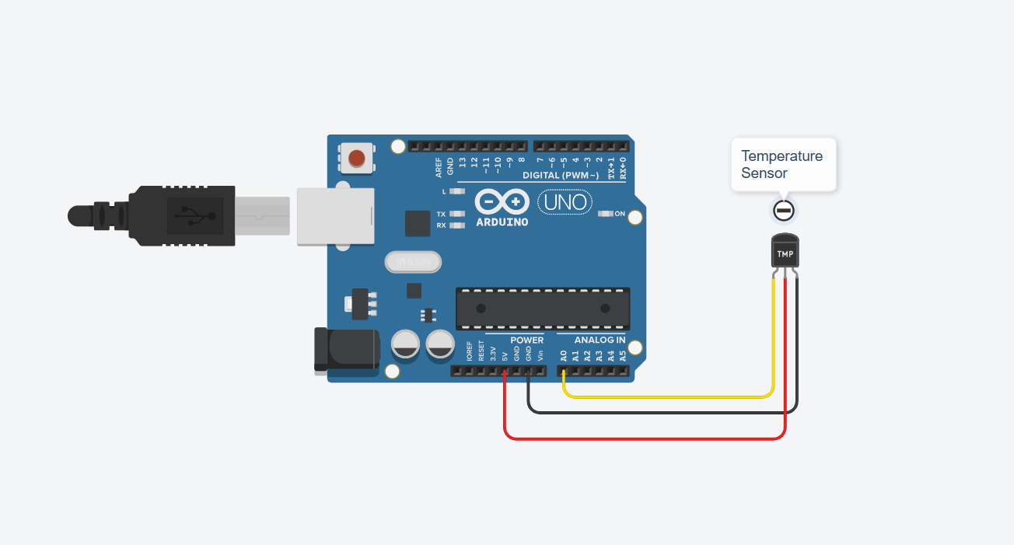
Figure 3: DHT11 Sensor.

// --- DHT11 Sensor Code ---
#include <DHT.h>

#define DHTPIN A0 // DHT11 data connected to analog pin A0
#define DHTTYPE DHT11

DHT dht(DHTPIN, DHTTYPE);

void setup() {
Serial.begin(9600);
Serial.println("DHT11 Test Initialized");
dht.begin();
}

void loop() {
delay(2000); // Wait 2 seconds between readings
float h = dht.readHumidity(); // Read humidity
float t = dht.readTemperature(); // Read temperature (°C)

if (isnan(h) || isnan(t)) {
Serial.println("Failed to read from DHT sensor!");
return;
}

Serial.print("Humidity: ");
Serial.print(h);
Serial.print(" %\t");
Serial.print("Temperature: ");
Serial.print(t);
Serial.println(" *C");
}

- DHT11 Temperature and Humidity Sensor:
  - Connections:
    - DHT11 VCC → Arduino 5V,
    - DHT11 GND → Arduino GND,
    - DHT11 Data → Arduino Analog A0.
  - Code: Upload the following sketch to the Arduino.
  - Observation: Open the Serial Monitor. Point the sensor at an object and observe the real-time distance measurement in centimetres.

- RESULT AND OBSERVATION:
All three sensors were successfully interfaced with the Arduino UNO. The experiments provided a clear, practical understanding of how to acquire binary proximity data from the IR sensor, quantitative distance data from the ultrasonic sensor, and environmental data (temperature and humidity) from the DHT11 sensor. The results displayed on the Serial Monitor were stable and responded correctly to external stimuli.

